TAKE-HOME FINAL EXAMINATION

SEPTEMBER 2022 SEMESTER

SUBJECT CODE | : | ELL 322
SUBJECT NAME | : | LINGUISTICS FOR LANGUAGE TEACHER
LEVEL | : | BACHELOR
INSTRUCTIONS TO CANDIDATES

1. Please read the instructions given in the question paper CAREFULLY.

2. Plagiarism in all forms is forbidden. Students who submit plagiarised work will be penalised.

3. Answer ALL questions.

4. Submit your answers ON or BEFORE 25th December 2022, 9.00 am.

5. Please submit your answers via myPLS (online submission).

6. Only ONE online submission is allowed.

7. Use the Microsoft Word template given at the end of the question paper.

8. Convert your MS Word to a PDF file and Submit

9. Save Filename as: NAME_SUBJECT CODE _STUDENT ID

TOTAL: 40 Marks

INSTRUCTIONS: Answer ALL Questions

QUESTION 1
Identify the five (5) component of language in linguistic and the identify the comment mistake made by student for each of the component.

Write a 400-words essay that discusses on the importance for English teachers to possess the knowledge of linguistics and its significant impact to their ESL teaching. Elaborate and support your answer with relevant examples that can be taken from your real life experience of being both teachers and learners of English as a second language.

[20 marks]
.

QUESTION 2

Human beings are capable of producing an infinite number of sounds that can be used to form various languages. This is achieved through a set of speech organs as shown in Figure 2 below:
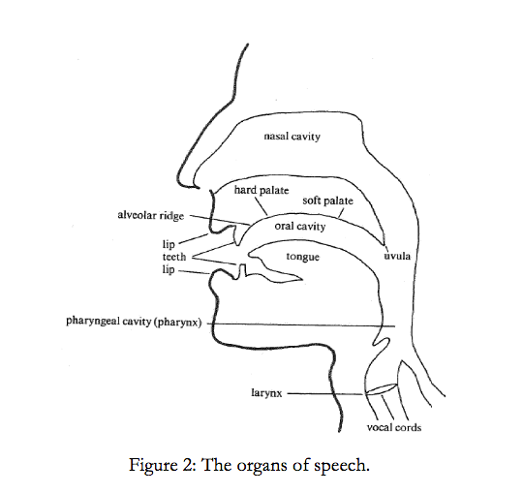

In 400 words, explain the function of five (5) speech organs and illustrate how these organs contribute to the production of sound in the English language. Elaborate and support your answer with relevant examples.

[10 marks]

QUESTION 3

Distinguish between prescriptive grammar vs descriptive grammar in linguistic.
Write 300-400words essay that explains in details the to what extend prescriptive and descriptive may differ. Provide relevant examples to further support your answer must be related with your experience in teaching.

[10 marks]

END OF QUESTION PAPER

ANSWER SHEET

DECLARATION BY STUDENT

I certify that this is my own work. I have not consulted with anyone or discussed the contents of this exam with anyone. The content has not been previously submitted for assessment to Asia e University or elsewhere. To do otherwise would constitute academic dishonesty. I also confirm that I have kept a copy of this assignment.
Name: __________________________________
Date: ____________________________

STUDENT ID
STUDENT NAME
IC / PASSPORT NUMBER
SUBJECT CODE
SUBJECT NAME
PROGRAMME
DATE OF SUBMISSION
LEARNING LOCATION

Begin writing your answers in this page
(Font: Times New Roman, Size: 12, Line Spacing 1.5)

Question 1

Question 2

Question 3

