EXTENDED ASSIGNMENT

JANUARY 2020 SEMESTER

SUBJECT CODE | : | ECE 124
SUBJECT NAME | : | OBSERVATION AND ASSESSMENT IN THE  EARLY YEARS
LEVEL | : | GRADUATE DIPLOMA
INSTRUCTIONS TO CANDIDATES

1. Please read the instructions given in the question paper CAREFULLY.

2. Plagiarism in all forms is forbidden. Students who submit plagiarised
assignment will be panelised.

4. Answer ALL questions.

5. Submit your answers BEFORE SATURDAY, 2 MAY 2020, 11.00 am.

Please submit your answers via myAeU PLS (online submission).

6. ONLY one online submission is allowed.

7. Use the Microsoft Word template given at the end of question paper.

8. Save Filename as: YOUR NAME

TOTAL 40 Marks
INSTRUCTIONS:
Answer ALL Questions
Jawab SEMUA Soalan

Question 1 (Answer in 400 words / Jawab dengan 400 patah perkataan)

Discuss the different types of observation techniques used to assess children and state how you would use these techniques in an ethical manner.

Bincangkan pelbagai jenis teknik pemerhatian yang digunakan untuk mentaksir kanak-kanak dan nyatakan bagaimana anda menggunakan teknik-teknik tersebut dengan cara beretika

[Total: 13 Marks]

Question 2 (Answer in 400 words / Jawab dengan 400 patah perkataan)

Critically discuss the steps you would take when making good teacher-made tests in early childhood education. Provide specific examples.

Bincangkan secara kritis langkah-langkah anda akan mengambil untuk membuat ujian-penggubalan guru yang baik dalam pendidikan awal kanak-kanak. Berikan contoh-contoh spesifik]

[Total: 13 Marks]

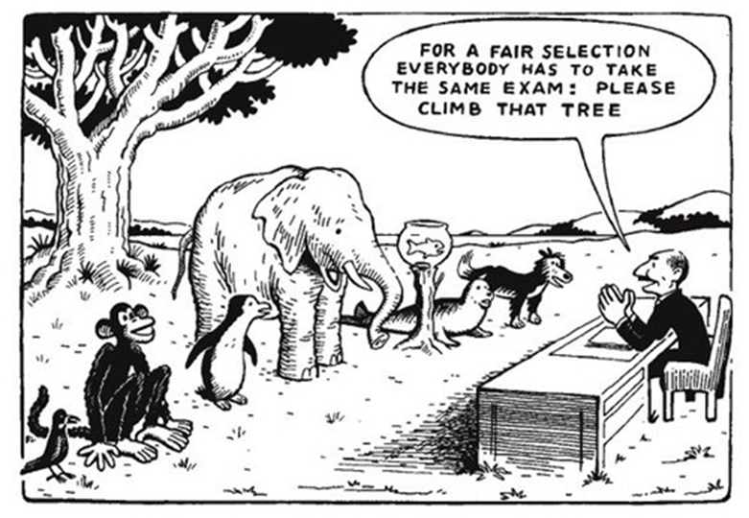

Terjamahan:

“Untuk memilih dengan
adil, setiap antara kamu
dikehendaki mengambil
peperiksaan yang sama.

Sila naik pokok itu”

Question 2 (Answer in 450 words / Jawab dengan 450 patah perkataan)

Interpret the above cartoon and its application in the classroom. Provide specific examples.

[Tafsir katun di atas dan aplikasinya dalam bilik darjah. Berikan contoh-contoh spesifik]

[Total: 13 Marks]

END OF QUESTION PAPER

ANSWER SHEET

DECLARATION BY STUDENT

I certify that this assignment is my own work. The content has not been previously submitted for assessment to Asia e University or elsewhere. I also confirm that I have kept a copy of this assignment.
Name: __________________________________
Student ID: ____________________________
Date: ____________________________

STUDENT ID
STUDENT NAME
IC / PASSPORT NUMBER
SUBJECT CODE
SUBJECT NAME
PROGRAMME
DATE OF SUBMISSION
LEARNING LOCATION

Begin writing your answers in this page
(Font: Times New Roman, Size: 12, Line Spacing 1.5)

Question 1

Question 2

Question 3

